BUSINESS DATA ANALYSIS FOR CUSTOMER, PRODUCT AND MARKET DECISION-MAKING
A Case Study of the Online Retail II Dataset

Name: ZHANG QIAN
Number: P167345
Course: STQD6324 Data Management
Programme: Master of Data Science and Analytics
University: Universiti Kebangsaan Malaysia
Submission Date: 19 June 2026

Table of Contents
Executive Summary 3
1.0 Introduction 3
1.1 Background and Industry Relevance 3
1.2 Aim, Objectives and Research Questions 4
2.0 Methodology 4
2.1 Dataset Source, Context and Suitability 4
2.2 Tools and Data Workflow 5
2.3 Data Cleaning and Preprocessing 6
2.4 Analytical Measures 6
3.0 Analysis and Findings 7
3.1 Monthly Sales Trend 7
3.2 Sales Performance Across Countries 7
3.3 Top-Selling Products 8
3.4 Average Order Value by Country 8
4.0 Integrated Discussion and Business Implications 9
5.0 Recommendations 9
6.0 Conclusion 10
References 10
Appendix: Project Files and Reproducibility 11

Executive Summary
This report presents a business-oriented data management and analytical project using the Online Retail II dataset. The study examines how raw transaction data can be transformed into evidence for sales planning, product management, customer value assessment and market development. The dataset was stored in the Hadoop Distributed File System (HDFS), processed with Apache Hive, and visualised in Apache Zeppelin.
The raw Hive table contained 1,067,372 rows, including one header row. Following the removal of incomplete customer records, cancelled transactions, non-positive quantities or prices, missing product descriptions and duplicate rows, 779,425 valid transaction records were retained. The cleaned data were then used to calculate monthly revenue, country-level revenue, product-level revenue and average order value.
The results indicate stronger revenue in the later months of the year, substantial dependence on the United Kingdom, revenue concentration among a small group of products, and comparatively high average order values in several overseas markets. Based on these findings, the report recommends earlier seasonal inventory preparation, selective development of established overseas markets, stronger management of high-revenue products and targeted treatment of high-value customer groups. Because the dataset does not contain marketing exposure, demographics, website activity or profit data, the findings should be interpreted as descriptive patterns rather than causal explanations of purchasing behaviour.

1.0 Introduction

1.1 Background and Industry Relevance
Retail and wholesale businesses generate large volumes of transaction data through routine sales activities. When these records are properly stored, cleaned and analysed, they can support decisions concerning inventory, product portfolios, customer prioritisation and geographic market development. This topic is aligned with the author's professional background in marketing and sales and with a future career direction involving data-informed commercial decision-making.
The project therefore focuses on both technical data management and business interpretation. HDFS and Hive provide a structured workflow for storing and querying the raw data, while Zeppelin visualisations communicate the resulting patterns. The report evaluates what the historical transactions reveal, identifies their managerial implications and acknowledges the limits of conclusions that can be drawn from transactional data alone.

1.2 Aim, Objectives and Research Questions
The aim of this project is to develop a reproducible data management workflow and use the cleaned Online Retail II data to generate practical insights for commercial decision-making.
The project has four objectives:
- To ingest and manage the raw transaction data in the Hadoop ecosystem.
- To identify and address missing values, cancellations, invalid values and duplicate records.
- To evaluate sales patterns across time, countries and products and to compare average order value across markets.
- To translate the analytical findings into realistic business recommendations.
The analysis addresses the following research questions:
RQ1: How does monthly sales revenue vary across the available time period?
RQ2: Which countries contribute the highest total revenue?
RQ3: Which products generate the highest sales revenue?
RQ4: Which countries show the highest average order value among markets with at least 20 valid orders?

2.0 Methodology

2.1 Dataset Source, Context and Suitability
The analysis uses the Online Retail II dataset, originally published by the UCI Machine Learning Repository and accessed through a Kaggle mirror. It contains 1,067,371 transactions from a United Kingdom-based, non-store retailer between 1 December 2009 and 9 December 2011. The retailer sells giftware, and many of its customers are wholesalers (Chen, 2012). The raw tab-separated file used for Hive ingestion also contained one header row, producing 1,067,372 rows in the initial raw table.
The dataset is suitable because it is sufficiently large, contains multiple commercial dimensions, and includes realistic data quality problems. Transaction identifiers support order-level analysis; customer identifiers support customer-level aggregation; stock codes and descriptions support product analysis; and country fields support market comparison. Prices are expressed in pounds sterling (GBP) in the source dataset.
Table 1. Variables used in the analysis
Column | Description
Invoice | Invoice or transaction number; codes beginning with C indicate cancellations
Stock_code | Product identifier
Description | Product description
Quantity | Number of units recorded in the transaction line
Invoice_date | Date and time of the transaction
Price | Unit price in GBP
Customer_id | Customer identifier
Country | Customer country

The dataset also has limitations. It represents one retailer and therefore cannot be assumed to describe the wider retail industry. It does not include customer demographics, marketing expenditure, website traffic, acquisition channels, product costs or customer feedback. Consequently, this study evaluates observed transaction patterns but does not estimate causal purchase drivers, profitability or campaign effectiveness.

2.2 Tools and Data Workflow
The dataset was uploaded to HDFS and queried through Apache Hive. Hive was selected because it supports SQL-based reading, writing and management of data in distributed storage (Apache Software Foundation, n.d.-a). Apache Zeppelin was used to execute Hive queries and create visual outputs; Zeppelin supports data ingestion, transformation, analytics and visualisation through multiple interpreter back ends (Apache Software Foundation, n.d.-c). PuTTY provided access to the Hadoop sandbox.
The workflow comprised the following stages:
1. Select the dataset and prepare it in a format suitable for Hive ingestion.
2. Upload the raw file to HDFS and create the final_report Hive database.
3. Create online_retail_raw with all source fields initially stored as STRING values.
4. Run data quality checks and create online_retail_cleaned using a CREATE TABLE AS SELECT statement.
5. Derive analytical variables and execute HiveQL aggregation queries.
6. Visualise the query outputs in Zeppelin and organise the scripts, figures and evidence for GitHub.

2.3 Data Cleaning and Preprocessing
All columns were initially stored as strings to prevent malformed or incomplete source values from interrupting ingestion. The cleaning query then converted quantity to INTEGER and price to DOUBLE after invalid records had been excluded. It also created sales_amount as quantity multiplied by price and derived order_year and order_month from invoice_date.
Table 2. Data quality checks performed in Hive
Data quality issue | Observed count
Header row in raw table | 1 row
Missing customer_id | 243,007 rows
Missing description | 4,382 rows
Cancelled orders | 19,494 rows
Quantity less than or equal to zero | 22,950 rows
Price less than or equal to zero | 6,207 rows
Duplicate rows | 34,335 rows

The issue counts in Table 2 are diagnostic counts and are not mutually exclusive; a single record may satisfy more than one condition. The cleaned table excluded the header, missing customer identifiers, missing descriptions, cancelled invoices, non-positive quantities, non-positive prices and exact duplicate rows. This produced 779,425 valid rows, equivalent to approximately 73.0% of the raw-table row count.
No positive transaction was removed solely because its quantity or price appeared unusually high. This was a deliberate choice because the source includes wholesale customers, for whom large orders may be legitimate. Nevertheless, retaining such values means that aggregate revenue and average order value may remain sensitive to unusually large transactions.

2.4 Analytical Measures
Sales revenue was calculated at transaction-line level as quantity multiplied by unit price. Monthly sales were calculated by summing sales_amount by order year and month. Country and product performance were assessed by total revenue. Average order value (AOV) was calculated as total country revenue divided by the number of distinct invoices. To reduce unstable rankings based on very small samples, the AOV comparison included only countries with at least 20 valid orders.

3.0 Analysis and Findings

3.1 Monthly Sales Trend
Monthly sales revenue was aggregated by year and month to identify temporal patterns. Figure 1 indicates that revenue was generally stronger toward the end of the year, with particularly high values around October and November in the two complete calendar years. The result is consistent with increased demand before the year-end shopping period; however, the transaction data alone cannot confirm the cause of this pattern.
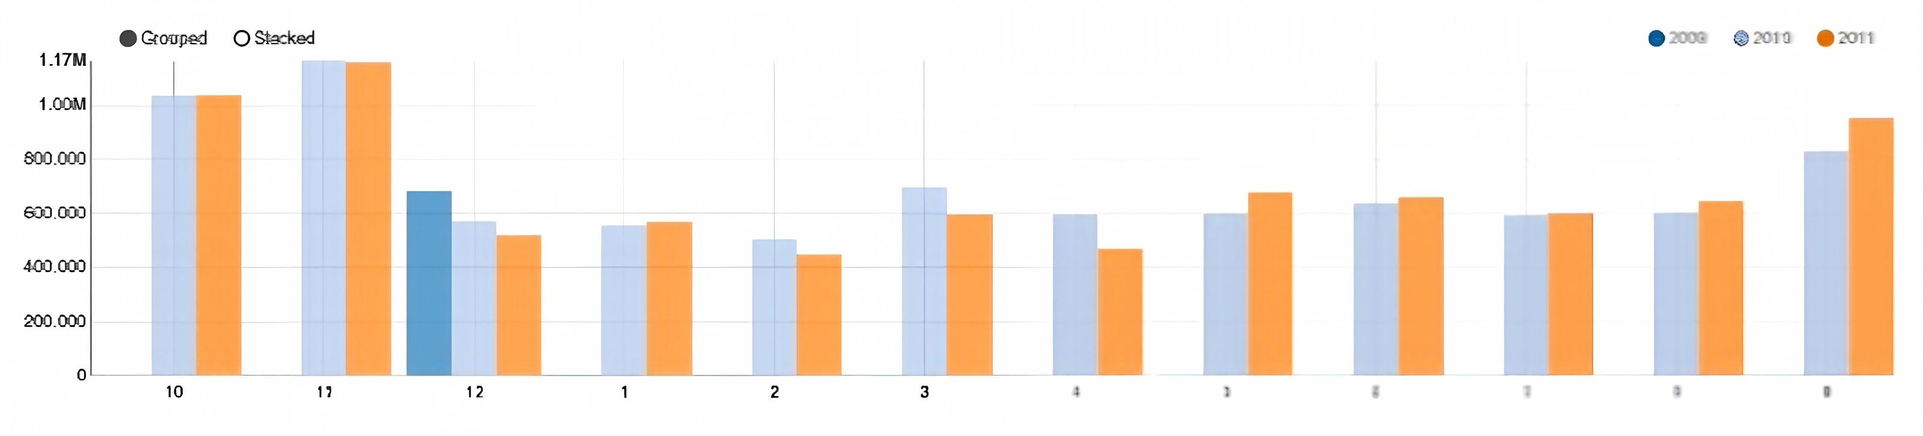
Figure 1. Monthly sales revenue by year and month.
Operationally, the pattern suggests that inventory, staffing and campaign preparation should begin before the observed peak months. It also indicates that comparisons of product or market performance should account for seasonality rather than relying only on annual totals.

3.2 Sales Performance Across Countries
Country-level revenue was calculated by summing sales_amount for each customer country. As shown in Figure 2, the United Kingdom generated approximately GBP 14.4 million and substantially exceeded every other market. EIRE, the Netherlands, Germany and France formed the next group of active markets, although their revenue was much lower.
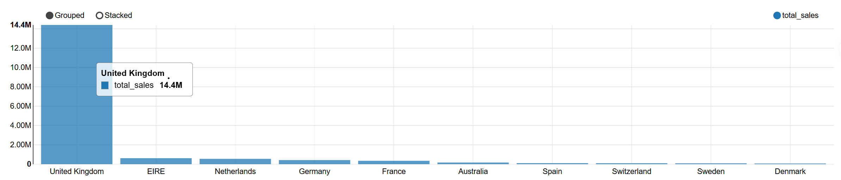
Figure 2. Top ten countries by total sales revenue.
The result confirms the commercial importance of the domestic market but also indicates concentration risk. The overseas markets already generating meaningful revenue provide more defensible expansion targets than countries with little observed activity, because they demonstrate existing demand in the historical data.

3.3 Top-Selling Products
Product performance was assessed by aggregating sales_amount by stock code and product description. The table output in Figure 3a preserves the full product names, while Figure 3b provides a visual comparison of the revenue totals.
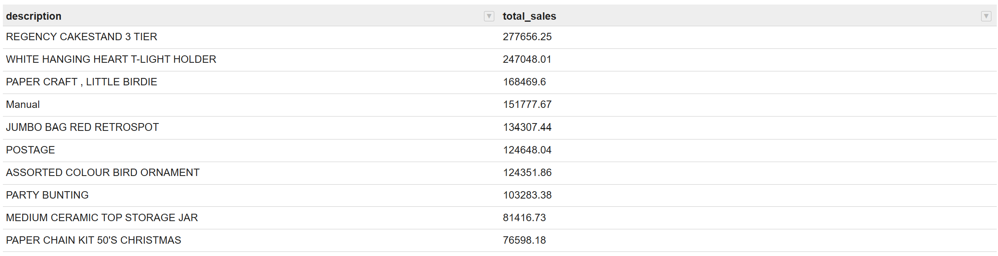
Figure 3a. Top products ranked by total sales revenue.
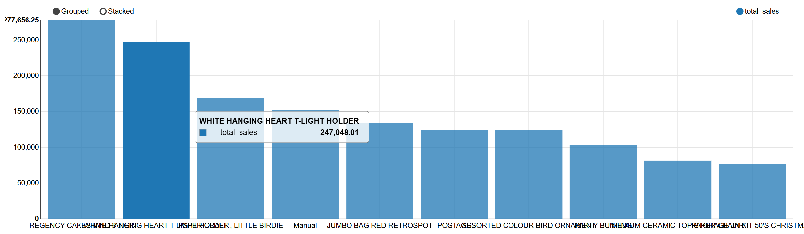
Figure 3b. Revenue comparison for the top-selling products.
REGENCY CAKESTAND 3 TIER and WHITE HANGING HEART T-LIGHT HOLDER were among the highest-revenue products. Their performance suggests that a limited group of products contributes disproportionately to sales. These items therefore require careful availability planning, although revenue alone should not be treated as profit because product cost and margin data are absent.

3.4 Average Order Value by Country
Total revenue does not fully represent market value because a smaller market may contain customers who place comparatively large orders. Figure 4 therefore compares AOV across countries with at least 20 valid invoices.
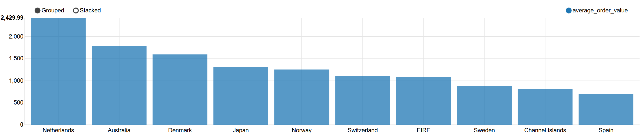
Figure 4. Average order value by country for markets with at least 20 valid orders.
The Netherlands recorded the highest AOV at approximately GBP 2,429.99, followed by Australia, Denmark, Japan and Norway. These results identify markets in which the typical invoice value was high even when total revenue was below that of the United Kingdom. The metric should nevertheless be interpreted cautiously because it may be influenced by wholesale ordering patterns and unusually large invoices.

4.0 Integrated Discussion and Business Implications
Taken together, the findings describe a business with seasonal demand, strong geographic concentration, reliance on a group of high-revenue products and meaningful variation in order value across countries. These patterns have connected implications for commercial planning.
First, the year-end revenue increase links demand forecasting to inventory timing. Replenishment decisions based only on average monthly sales may underprepare the business for peak demand. Second, the United Kingdom's dominance provides scale but also exposes the retailer to market-specific changes. Existing overseas markets offer diversification opportunities, but their potential should be evaluated using both total revenue and order value.
Third, high-revenue products can support acquisition campaigns and product bundles, but the absence of cost data prevents a profitability ranking. Finally, high AOV in several overseas markets may reflect valuable customer groups or wholesale orders. Further customer-level analysis would be useful before designing personalised retention programmes.

5.0 Recommendations
Recommendation 1: Prepare for peak demand earlier. Use the historical monthly pattern to begin stock replenishment, staffing and campaign preparation one to two months before October and November. Performance should be monitored weekly during the peak period so that purchasing plans can be adjusted.
Recommendation 2: Develop proven overseas markets selectively. Maintain the United Kingdom as the core market while testing targeted offers in EIRE, the Netherlands, Germany and France. Market development should begin with small, measurable campaigns and should be evaluated using revenue, order count and AOV.
Recommendation 3: Protect availability of high-revenue products. Set appropriate reorder points for the strongest products and review their stock position before peak months. Bundling popular items with slower-moving products may support category sales, but product margin data should be added before finalising the offer.
Recommendation 4: Validate high-AOV customer opportunities. Examine the customers and invoices behind high-AOV markets, particularly the Netherlands and Australia, before applying premium offers or retention programmes. A customer-level RFM analysis would help distinguish repeat high-value customers from isolated large wholesale orders.
Recommendation 5: Strengthen future data collection. Integrate marketing channel, product cost, delivery, website activity and customer feedback data. These variables would allow future analyses to move beyond descriptive sales patterns toward purchase-driver, profitability and campaign-effectiveness analysis.

6.0 Conclusion
This project demonstrates an end-to-end data management workflow using the Online Retail II dataset, HDFS, Apache Hive and Apache Zeppelin. Of the 1,067,372 rows loaded into the raw Hive table, 779,425 valid transaction records were retained after the documented cleaning rules were applied.
The analysis identified stronger year-end sales, a high dependence on the United Kingdom, revenue concentration among several products and high average order values in selected overseas markets. These findings support practical actions in inventory planning, market development, product management and customer prioritisation. At the same time, the report avoids treating transactional associations as causal purchase drivers. Enriching the data with marketing, cost and customer-interaction variables would enable deeper behavioural and profitability analysis in future work.

References
Apache Software Foundation. (n.d.-a). Apache Hive. https://hive.apache.org/
Apache Software Foundation. (n.d.-b). HDFS users guide. https://hadoop.apache.org/docs/stable/hadoop-project-dist/hadoop-hdfs/HdfsUserGuide.html
Apache Software Foundation. (n.d.-c). Apache Zeppelin documentation. https://zeppelin.apache.org/docs/latest/
Chen, D. (2012). Online Retail II [Data set]. UCI Machine Learning Repository. https://doi.org/10.24432/C5CG6D
Kaggle. (n.d.). Online Retail II UCI [Data set]. https://www.kaggle.com/datasets/mashlyn/online-retail-ii-uci

Appendix: Project Files and Reproducibility
The accompanying GitHub repository should preserve the project workflow in a reproducible structure. The SQL scripts are stored under hive_scripts/, generated visualisations under figures/, and process evidence under screenshots/. The repository README documents the project background, objectives, workflow, cleaning rules, findings and recommendations.
Before submission, the repository should also include the final report, the source-data instructions or download link, and a clear execution order for the three Hive scripts. The lecturer should be added as a collaborator using the email address stated in the assignment brief.

